**Project work Diary**

Date:04/11/2019

# Tasks

* I got mininet running today and I am beginning to set up my virtual network
* I set up a network with a controller a switch and three hosts
* This is an example of the simple network I set up

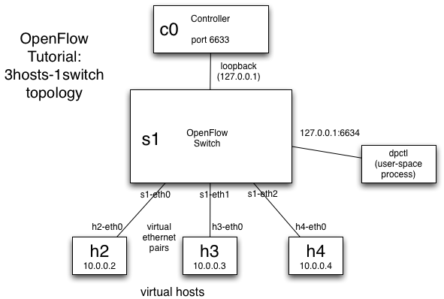

# Reflection

* I ran commands which set up the network on the virtual machine

# Issues:

*Software:*

* Some of the commands did not work as desired so I needed to do more research to find out why this was happening

# Solutions

*Software:*

* I needed to change the configuration settings for the VM to run these commands